Camso Maintenance Activities

In Library-ESP Specification

Download ESP0021 - Windchill Dashboard

Go to tasks. Select frequence as **Weekly**

1. **Vaults/ Folders status**

On USCHAS73 (Production) validate on SQL-List-folder status, if all the folders are valid and enabled.

1. **Vaults Validate Revaulting**

Go to the revaulting tab.

Take remote of caw00284.

In C: there is a folder ‘Maintenance’

You will find some SQL queries there.

Run the revaulting query as given below:

**Revaulting**

(select sq.name, sq.queuestate, sq.enabled, se.codec5 , to_char(se.scheduletime,'dd.mm.yyyy hh24:mi:ss') from SCHEDULEQUEUE sq, SCHEDULEQUEUEENTRY se where sq.name IN ('RevaultingQueue', 'replQueue') AND sq.ida2a2 = se.ida3a5) UNION ALL (select pq.name, pq.queuestate, pq.enabled, null, null FROM PROCESSINGQUEUE PQ WHERE PQ.NAME LIKE 'wt.router.%')

Generate the result.

And paste it in the left table.

Run the below query and paste the result in the right table.

**Synchro**

SELECT ScheduleType, RevaultingSessionIDA2A2, Target, ExecutionStartTime, CompletionTime, current_status, totalruns as TotalItems, runs_executed as Executed, error_executed as Errors FROM ( SELECT SI.ITEMNAME AS SCHEDULETYPE, RS.IDA2A2 AS REVAULTINGSESSIONIDA2A2, SI.ITEMDESCRIPTION AS TARGET, RS.EXECUTIONSTARTTIME AS EXECUTIONSTARTTIMESORT, TO_CHAR(RS.EXECUTIONSTARTTIME,'DD.MM.YYYY HH24:MI:SS') AS EXECUTIONSTARTTIME, TO_CHAR(RS.COMPLETIONTIME,'DD.MM.YYYY HH24:MI:SS') AS COMPLETIONTIME, RS.CODEA4 AS CURRENT_STATUS, RS.TOTALRUNS, RS.NUMBEREXECUTED AS RUNS_EXECUTED, RS.NUMERROREXECUTED AS ERROR_EXECUTED FROM revaultingsession rs INNER JOIN scheduleitem si ON rs.ida3b4=si.ida2a2 WHERE (si.queuename='RevaultingQueue' AND si.targetmethod!='reVaulting') UNION ALL SELECT SI.ITEMNAME AS SCHEDULETYPE, RS.IDA2A2 AS REVAULTINGSESSIONIDA2A2, FV.NAME AS TARGET, RS.EXECUTIONSTARTTIME AS EXECUTIONSTARTTIMESORT, TO_CHAR(RS.EXECUTIONSTARTTIME,'DD.MM.YYYY HH24:MI:SS') AS EXECUTIONSTARTTIME, TO_CHAR(RS.COMPLETIONTIME,'DD.MM.YYYY HH24:MI:SS') AS COMPLETIONTIME, RS.CODEA4 AS CURRENT_STATUS, RS.TOTALRUNS, RS.NUMBEREXECUTED AS RUNS_EXECUTED, RS.NUMERROREXECUTED AS ERROR_EXECUTED FROM (((revaultingsession rs INNER JOIN scheduleitem si ON rs.ida3b4=si.ida2a2) INNER JOIN persistantarg pe ON si.ida2a2= pe.ida3a4) INNER JOIN fvvault fv ON fv.ida2a2= pe.ida3a5) WHERE (si.targetmethod='reVaulting') ) ORDER BY ExecutionStartTimeSort DESC;

1. **Windchill Server Memory and CPU/Status**

Check the windchill server status, server memory and system status.

1. **Windchill Server Queues Cleanup**

Go to Queue Management

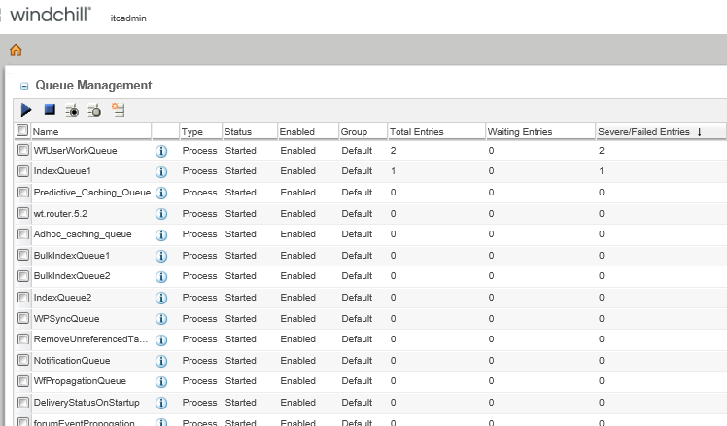

Sort by severity.

Reset the queue entries. If still the entry is in severe state, examine the error and resolve.

1. **Replication**

Go to the replication tab.

Execute the below query on caw00284:

SELECT CRS.NAME AS SCHEDULENAME, CRS.STATUS, RV.NAME AS VAULT_NAME, TO_CHAR(CRH.EXECUTIONSTARTTIME,'DD.MM.YYYY HH24:MI:SS') AS EXECUTIONSTARTTIME, TO_CHAR(CRH.COMPLETIONTIME,'DD.MM.YYYY HH24:MI:SS') AS COMPLETIONTIME, CRH.CODEA4 AS CURRENT_STATUS, CRH.TOTALRUNS AS TOTALITEMS, CRH.NUMBEREXECUTED AS EXECUTED, CRH.NUMERROREXECUTED AS ERRORS FROM contentreplschedule crs, contreplhistory crh, replicavault rv, scheduleitem si WHERE CRS.IDA3THEREPLICAVAULTREFERENCE=RV.IDA2A2 AND CRH.IDA3B4=SI.IDA2A2 AND CRS.IDA3A6=SI.IDA2A2 ORDER BY crh.executionstarttime DESC, ScheduleName;

Paste the results in the Replication tab.

1. **Worker Purge & Restart**

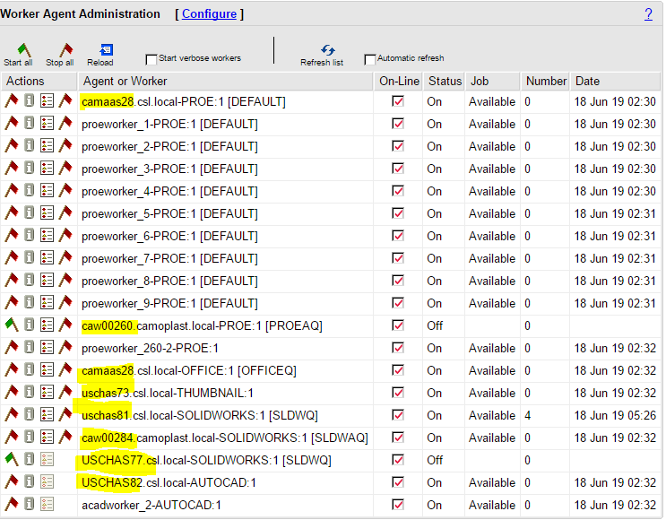

Login to the highlighted Worker machines.

On the desktop there is a purge file. Run the file.

Start the worker in foreground.

Restart all the machines selecting the option ‘Planned Maintenance’

Go to tasks. Select frequence as **Monthly**

1. **Vaults Cleanup Unreferenced Items**

Log in to the production server(USCHAS73).

Run the below batch file to remove the Unreferenced files.

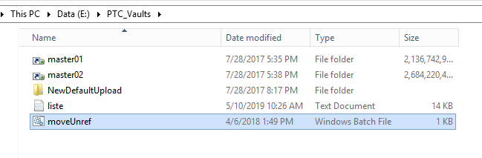

1. **Windchill Server Review LOGS**

Go to site🡪 utilities🡪 server status

Check for any error.

Check if the status of all replica file servers is OK.

1. **windchill wt.index.BulkIndexTool**

Execute the same command on Windchill shell.

Press 7- check bulk index progress

4- Reset failed entries

1-Start bulk index

1. **Cleanup Windows temp folder**

Click start🡪 Run

Type %temp%

Delete the contents.

1. **Clear Java Cache**

Run E:\PTC\Windchill_11.x\Java\jre\bin\javacpl.exe

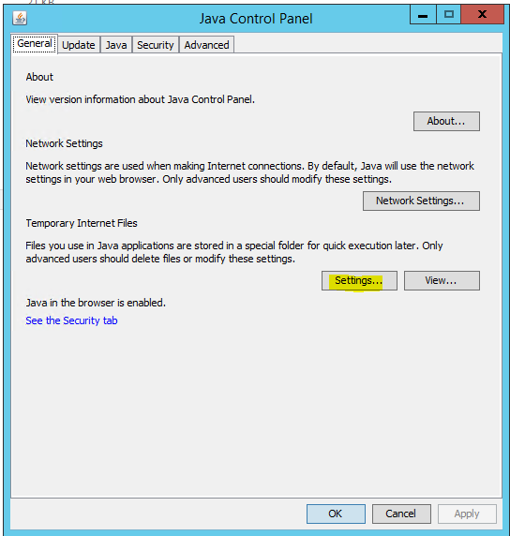

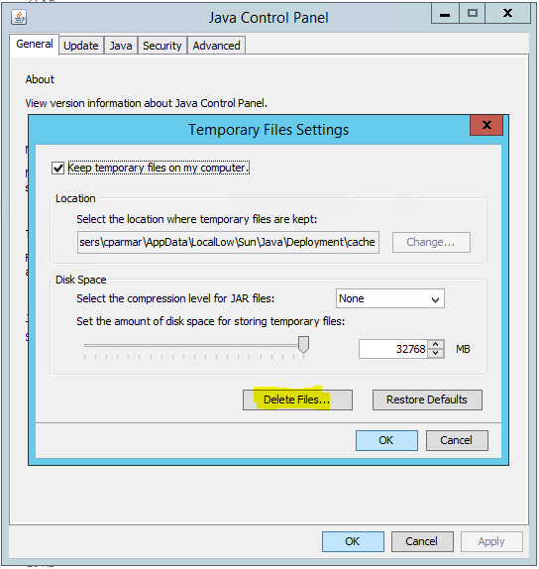

1. **Windchill validate invalid PBO**

Go to site🡪 utilities🡪 Workflow Process Administration

Find workflow process with invalid…

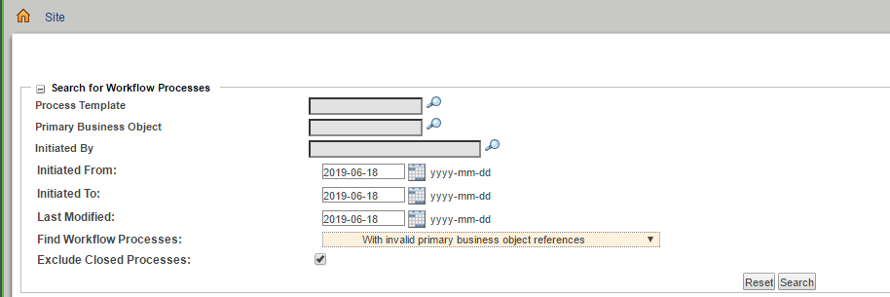

1. **Erase WVS temp folders older than 1 day**

Clear the pubtemp folder

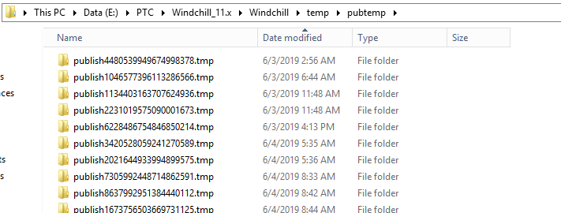

1. **Purge Participant Cache**

Go to site🡪 utilities🡪participant administration

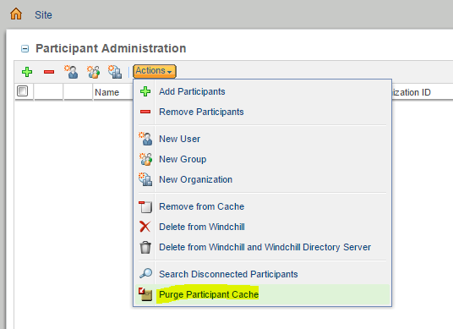

Save all the changes in the file ESP0021 - Windchill Dashboard.

From ESP Library, checkout and edit the same file, browse the updated file and checkin.